- Anurag Surve
Weekly Report – Week 2
Understanding EEG Data Using the CHB-MIT Scalp EEG Dataset

Week 2 Objective
The main goal of Week 2 was to understand EEG data at a fundamental level before doing any modeling or machine learning.
Instead of directly training models, the focus was on learning:
- What EEG data represents
- How EEG recordings are structured in files
- How seizures are annotated
- How normal EEG and seizure EEG differ visually and statistically
To achieve this, I selected the CHB-MIT Scalp EEG Dataset from PhysioNet.

Dataset Chosen: CHB-MIT Scalp EEG Dataset
The CHB-MIT dataset contains scalp EEG recordings collected from pediatric patients with epilepsy at Children’s Hospital Boston.
Key characteristics of the dataset:
- EEG recordings from 22 patients
- Each patient has multiple EEG recording files
- Seizure start and end times are manually annotated
- Data is commonly used in seizure detection research
Due to local storage limitations, only the first three patient folders were downloaded:
- chb01
- chb02
- chb03
This subset is sufficient for understanding EEG structure and seizure characteristics.

What Files Are Present in Each Patient Folder
Each patient folder contains the following types of files:
1. EDF Files (.edf)
Examples:
- chb01_01.edf
- chb01_02.edf
- chb01_03.edf
These are raw EEG recordings.
Each EDF file contains:
- Continuous EEG signals
- Multiple channels recorded simultaneously
- Usually 1 hour of data per file

2. Summary File (chb01-summary.txt)
This file contains:
- Channel names (electrode pairs)
- Seizure start and end times (in seconds)
- File-level metadata
This file is essential for knowing where seizures occur inside the EEG recordings.

What “Raw Multichannel EEG” Means
- EEG measures electrical activity of the brain.
- Raw means the signal is unfiltered and unprocessed.
- Multichannel means the brain activity is recorded from many locations at the same time.
In this dataset:
- Each file has 23 EEG channels
- Each channel records a separate signal over time
So, one EDF file is essentially:
23 brain signals recorded continuously for ~1 hour

Sampling Rate (256 Hz) – What It Means
The dataset uses a sampling rate of 256 Hz.
This means:
- Each channel records 256 data points per second
- In 1 minute → 256 × 60 = 15,360 samples per channel
- In 1 hour → ~921,600 samples per channel
So EEG data is:
- Very high-resolution
- Very dense
- Time-sensitive
This is why EEG analysis requires careful preprocessing.

Understanding Bipolar Montage Channels
The channels are listed like:
- FP1–F7
- F7–T7
- T7–P7
These are bipolar channels.
What this means:
- Each channel is the difference between two electrodes
- It measures how electrical activity changes between two brain locations
- This helps reduce noise and emphasize localized brain activity
So:
FP1–F7 is NOT one electrode — it is the voltage difference between FP1 and F7.

Understanding Seizure Start and End Times
Example from the summary file:
Seizure Start Time: 2996 seconds
Seizure End Time: 3036 seconds
This means:
- The seizure begins 2996 seconds after the start of that EDF file
- The seizure ends at 3036 seconds
- Duration = 40 seconds
If the file is 1 hour long:
- 2996 seconds ≈ 49 minutes and 56 seconds into the recording
This information allows us to:
- Extract seizure segments
- Compare seizure vs non-seizure EEG activity

Exploratory Data Analysis (EDA) in Python
Python was used to explore the EEG data visually and statistically.
The following analyses were performed:

1. Raw EEG Signal Visualization
Raw EEG signals were plotted for:
- Normal (non-seizure) segments
- Seizure segments
This helped visualize:
- Signal amplitude
- Noise patterns
- Differences in brain activity
Key observation:
- Seizure EEG shows higher amplitude
- Signals appear more synchronized during seizures
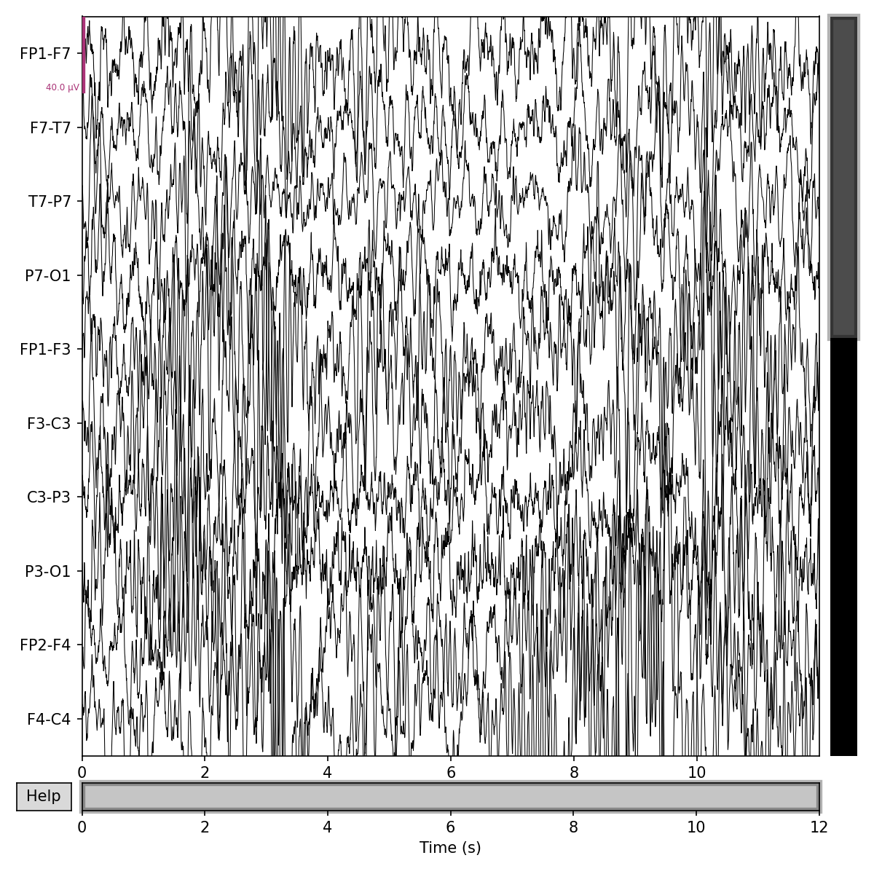
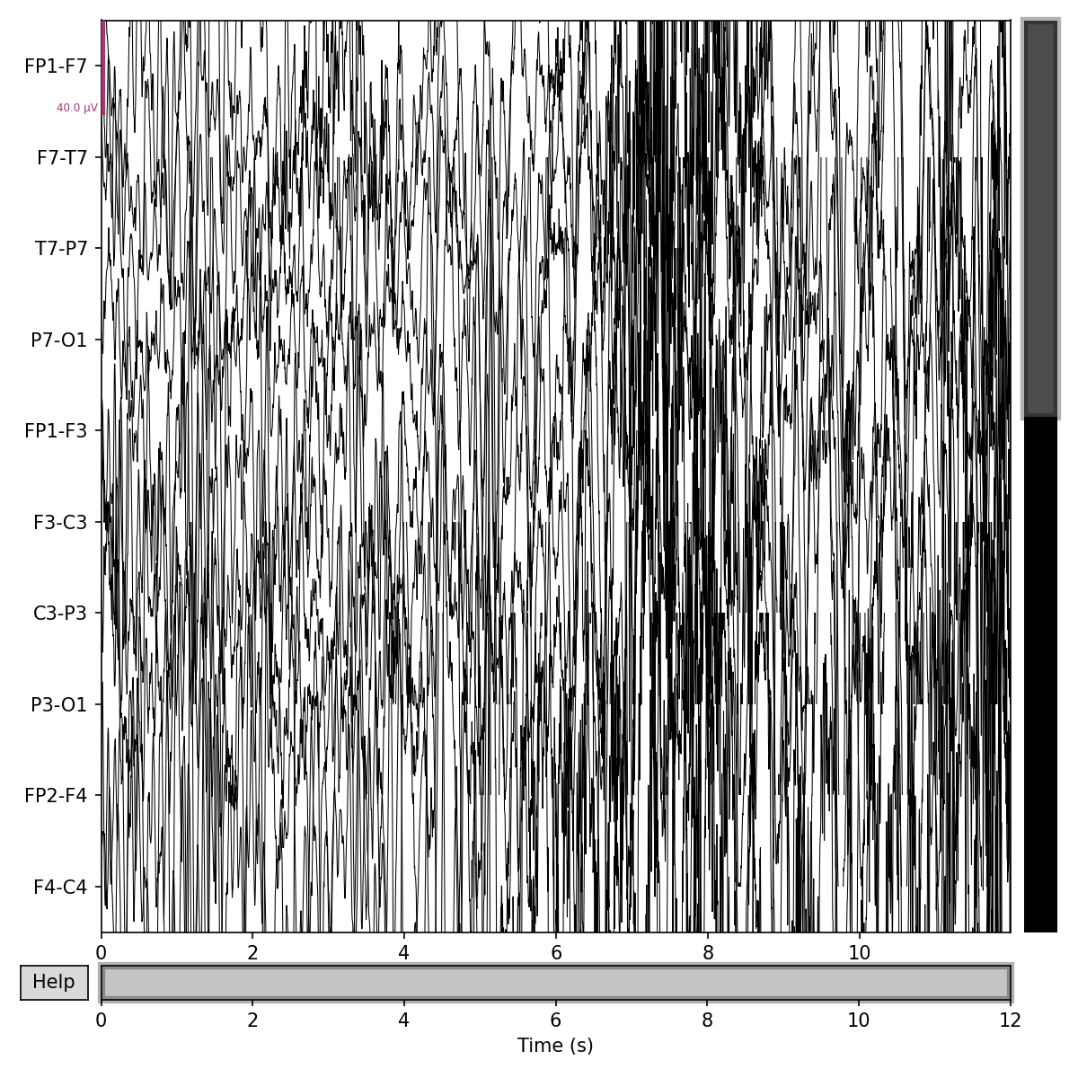

2. Power Spectral Density (PSD) Analysis
PSD shows how signal power is distributed across frequencies.
This analysis helps understand:
- Which frequency bands dominate
- How seizure activity differs spectrally
Key observation:
- Seizure segments show higher overall power
- Increased energy in certain frequency bands compared to normal EEG
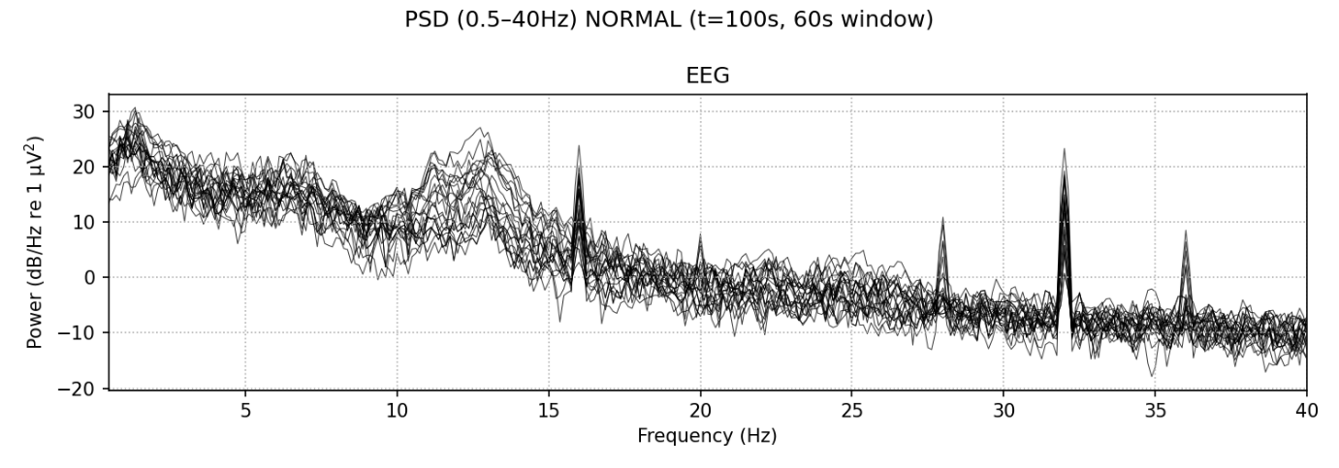
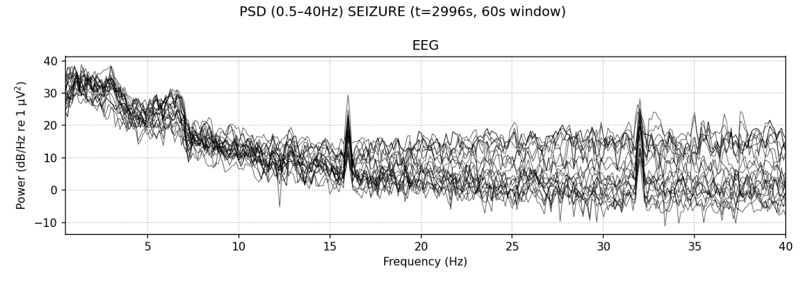

3. Time–Frequency Analysis (Spectrograms)
Spectrograms show:
- How frequency content changes over time
This is important because:
- Seizures are dynamic events
- Frequency patterns evolve during seizure onset and progression
Key observation:
- Seizure periods show stronger and denser frequency activity
- Clear temporal patterns emerge during seizures
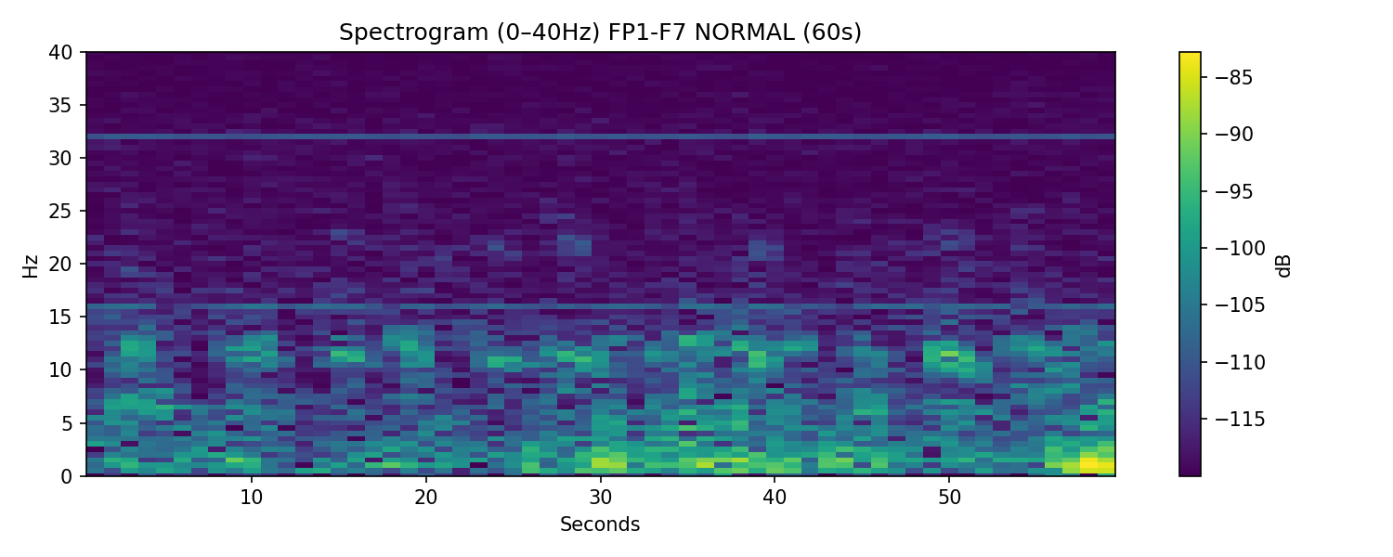

Key Learnings from Week 2
- EEG data is high-dimensional and time-dependent
- Each patient has unique EEG patterns
- Seizure EEG is visually and spectrally different from normal EEG
- Understanding the raw data is critical before applying ML or DL models

Conclusion
Week 2 was focused entirely on understanding the EEG data itself, not modeling.
By exploring:
- File structure
- Sampling rate
- Channel configuration
- Seizure annotations
- Visual and spectral characteristics
A strong foundation was established for future weeks, where preprocessing, feature extraction, and modeling can be performed more meaningfully.

